Millions of Ethiopian famine aid used to buy weapons

Millions of pounds of Western aid money intended to buy food for starving Ethiopians during the country's 1984 famine were instead used by rebels to buy weapons, an investigation has found.
Mike Pflanz in Nairobi Published: 1:09PM GMT 03 Mar 2010
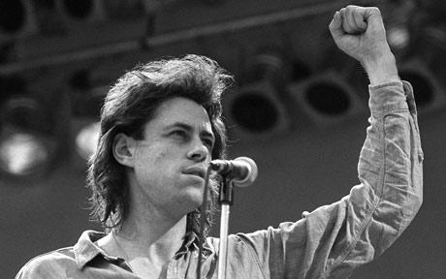
Bob Geldof talks on stage at Wembley Stadium at the beginning of Live Aid in 1985 Photo: AP

At least some of that money was likely to have come from the £150 million raised by Live Aid and Band Aid. More than three million copies of Do They Know It's Christmas sold in just five weeks in late 1984 to raise funds for the estimated eight million Ethiopians facing starvation. Up to a million died.
According to a report published on Wednesday, rebel soldiers disguised themselves as grain traders and handed over sacks of sand hidden beneath genuine food aid, in return for cash from Western donations.
The rebel army involved, headed by Ethiopia's current prime minister, Meles Zenawi, went on to overthrow Ethiopia's Marxist government and has run the country since.
Mr Meles has been one of Britain's most favoured African leaders after promising democratic reforms.
The investigation by the BBC, will raise further questions over Western support for Mr Meles and his ruling Ethiopian People's Revolutionary Democratic Front.
That party grew out of the Tigrayan People's Liberation Front, the rebel army given Western cash to buy food aid during the 1984-5 famine.
At the time, the Ethiopian Marxist government of Haile Mengistu Mariam refused to pass food to famine-hit civilians living in the north of the country, where a civil war was already years old and where a drought was biting hardest.
Instead, Europe and the US shipped food through Sudan and into the northern provinces of Tigray and Eritrea.
Some areas had surplus harvests, and food was bought from those farmers via a local aid group, the Relief Society of Tigray and trucked to famine-hit regions.
Max Peberdy, an aid worker in 1984 with Christian Aid, told the BBC that he carried more than $500,000 across the border into Ethiopia to buy food.
He insisted that there was "a complete separation" between cooperation from the rebel army and the "logistics" of buying food from local farmers.
But one of the traders who sold grain to Mr Peberdy directly, Gebremedhin Araya, said that he was in fact a senior rebel commander.
"I was given clothes to make me look like a Muslim merchant. This was a trick for the NGOs," he said, referring to non-governmental organisations, or aid agencies.
He said sacks filled with sand were hidden under a top layer of real grain bags.
Another man claiming to be a senior commander, Aregawi Berhe, said that "95 per cent" of the $100 million given to buy food was diverted to purchase weapons or to boost the rebels' cause.
"The aid workers were fooled," he said.
Recently declassified documents from the CIA support these claims.
"Some funds that insurgent organisations are raising for relief operations, as a result of increased world publicity, are almost certainly being diverted for military purposes," the Agency wrote in a secret 1985 report.
A spokesman for Mr Meles could not immediately be reached. A second Ethiopian government spokesman said that he had not yet seen the BBC report.
Source: http://www.telegraph.co.uk/news/worldnews/africaandindianocean/ethiopia/7359324/Millions-of-Ethiopian-famine-aid-used-to-buy-weapons.html

